
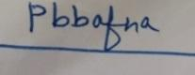
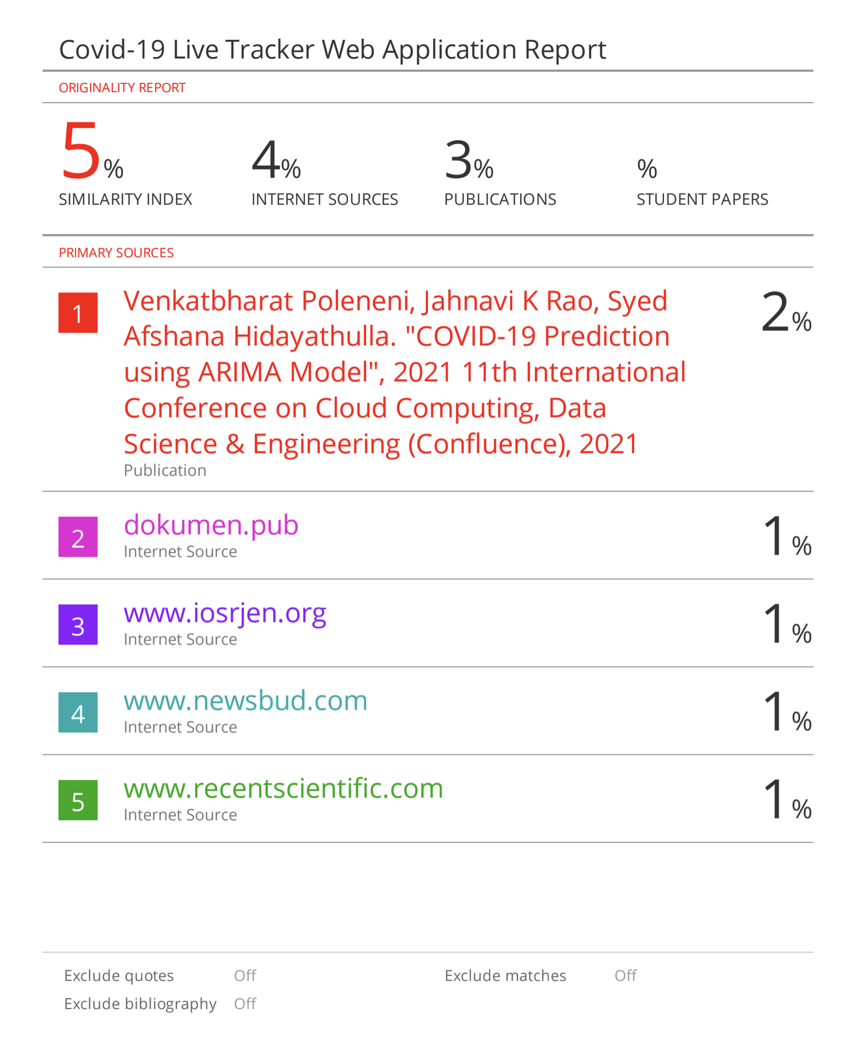
Undertaking from the UG/PG student(s) while submitting his/her final dissertation to his respective institute

Ref. No. _________
We, the following student(s)

Sr. No. | Sequence of students names on a dissertation | Students name | Name of the Institute & Place | Email & Mobile
1. | 1st student | Amal Sunil Pillai | SICSR | amp1921009@sicsr.ac.in  +91 7620035183
2. | 2nd student | Kriti Thakrar | SICSR | krt1921050@sicsr.ac.in  +91 8768776138
3. | 3rd student | Umang Agarwal | SICSR | uma1921093@sicsr.ac.in  +91 8299542882

hereby give an undertaking that the dissertation entitled Covid-19 Live Tracker Web Application has been checked for its Similarity Index/Plagiarism through __Turnitin___ software tool; and that the document has been prepared by us and it is our original work and free of any plagiarism.
It was found that:
1. | The Similarity Index (SI) was:  (Note: SI range: 0 to 10%; if SI is >10%, then authors cannot communicate ms; attachment of SI report is mandatory) | 5 %
2. | The ethical clearance for research work conducted obtained from:  (Note: Name the consent obtaining body; if ‘not applicable’ then write so) | NA
3. | The source of funding for research was:  (Note: Name the funding agency; or write ‘self’ if no funding source is involved) | NA
4. | Conflict of interest:  (Note: Tick √ whichever is applicable) | No
5. | The material (adopted text, tables, figures, graphs, etc.) as has been obtained from other sources, has been duly acknowledged in the manuscript:  (Note: Tick √ whichever is applicable) | No

In case if any of the above-furnished information is found false at any point in time, then the University authorities can take action as deemed fit against all of us.

Full Name & Signature of the student(s)  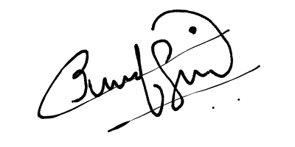  AMAL SUNIL PILLAI  KRITI THAKRAR  UMANG AGRAWAL | Mr.Prathamesh Lahande  Name & Signature of SIU Guide/Mentor
Date: 24/05/2021  Place: Pune | Endorsement by  Academic Integrity Committee (AIC)

